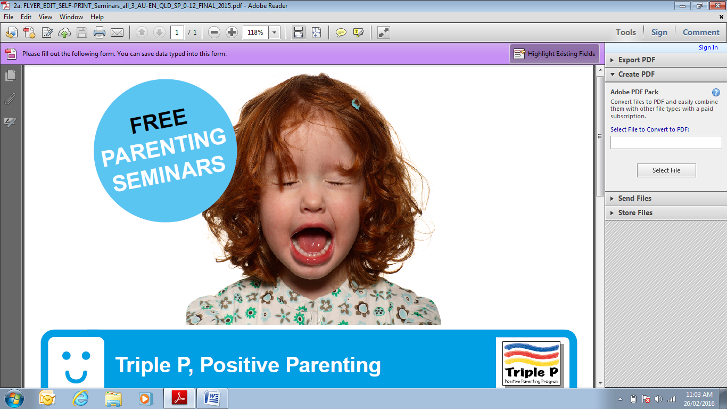

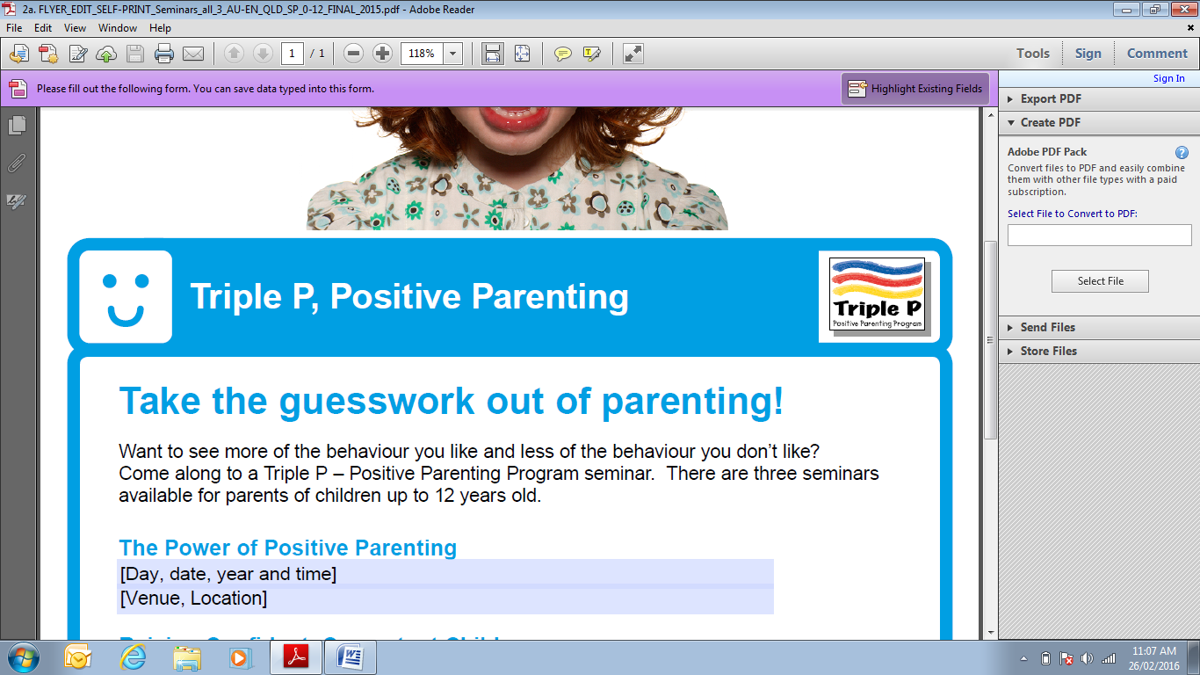

**Take the guesswork out of parenting!**

*Want to see more of the behaviour you like and less of the behaviour you don’t like? Come along to a Triple P – Positive Parenting Program seminar. There are seminars available for parents of children up to 12 years old.*

**The Power of Positive Parenting**

**WHEN:**  **Tuesday, 4 October 2016**

6.30pm –8.15pm

**WHERE:** C & K Aspley East Kindergarten

12 Clorane St West, ASPLEY QLD 4034

**Raising Confident, Competent Children**

**WHEN:**  **Tuesday, 11 October 2016**

6.30pm –8.15pm

**WHERE:** C & K Aspley East Kindergarten

12 Clorane St West, ASPLEY QLD 4034

**Raising Resilient Children**

**WHEN:**  **Tuesday, 18 October 2016**

6.30pm –8.15pm

**WHERE:** C & K Aspley East Kindergarten

12 Clorane St West, ASPLEY QLD 4034

*Find out more about why kids behave the way they do, and pick up tips and strategies to help make family life easier – and more fun!*

*Meet other parents too!*

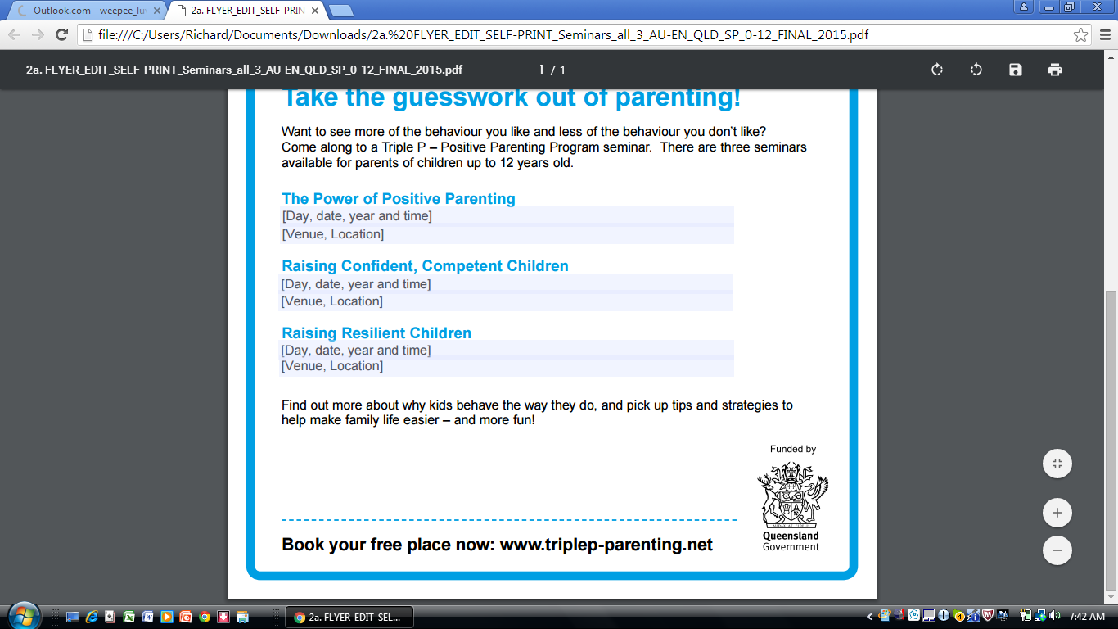

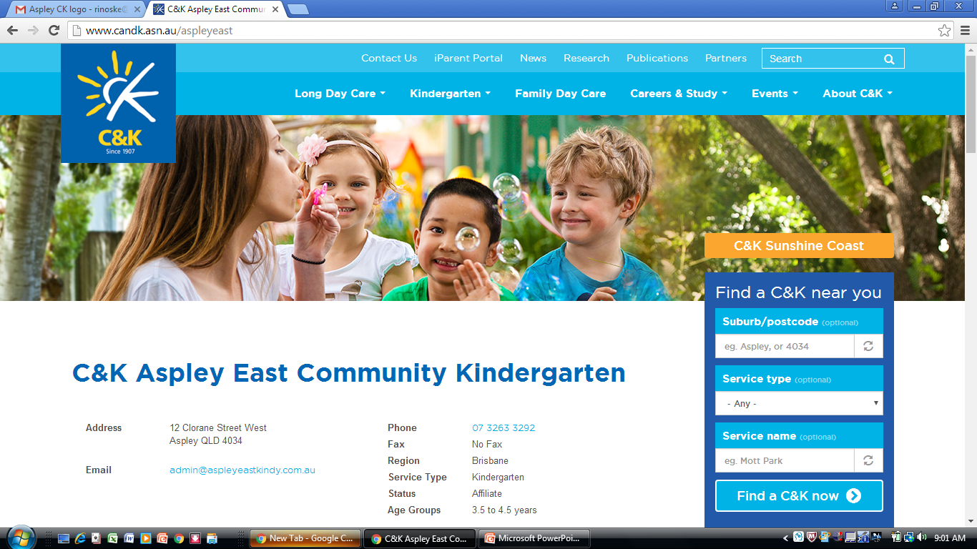**Book your free place now:**

**www.triplep-parenting.net**

**For more information, ring**

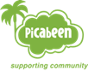**Picabeen Community Centre on 3354 2555**